**C PROGRAMMING ASSIGNMENT:**

**12**

DATE: 03.12.21

SUBMITTED BY: -

NAME: MUKTESH MISHRA

BRANCH: CSE

SECTION: B22

ROLL NO.: 21052258

**Program 1:** Write a program to print any character for n times using functions.

Code:

#include <stdio.h>

void disp(int n)

{

    for (int i = 0; i < n; i++)

    {

        printf("$\n");

    }

}

int main(int argc, char const *argv[])

{

    int a;

    printf("Enter no of times you want loop to execute in above function:\n");

    scanf("%d",&a);

    disp(a);

    return 0;

}

Output:

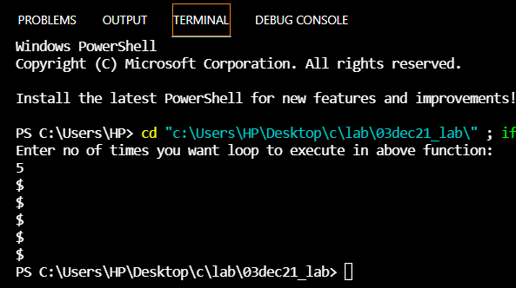

**Program 2:** Write a program to convert an lower case alphabet to upper case alphabet using functions.

Code:

#include <stdio.h>

// lower case to upper case

void lctouc(char ch)

{

    if (ch >= 'a' && ch <= 'z')

    {

        ch = (int)ch - 32;

        printf("%c", ch);

    }

    else

    {

        printf("invalid");

    }

}

int main(int argc, char const *argv[])

{

    char a;

    printf("Enter the character\n");

    scanf("%c", &a);

    lctouc(a);

    return 0;

}

Output:

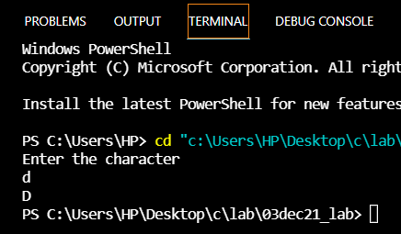

**Program 3:** Write a program to swap two numbers using functions

Code:

#include <stdio.h>

//swapping with func

void swap(int a, int b)

{

    printf("\nValues before swapping: %d %d", a, b);

    a = a + b;

    b = a - b;

    a = a - b;

    printf("\nValues after swapping: %d %d", a, b);

}

int main(int argc, char const *argv[])

{

    int x, y;

    printf("Enter the 2 numbers to be swapped\n");

    scanf("%d %d", &x, &y);

    swap(x,y);

    return 0;

}

Output:

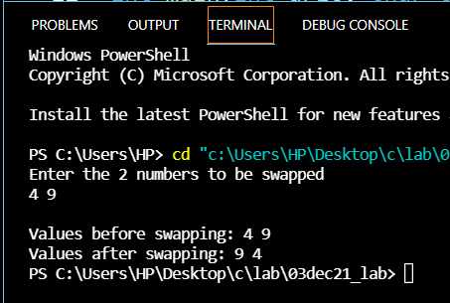

**Program 4:** Write a program to find roots of a quadratic equation using functions

Code:

#include <stdio.h>

#include <math.h>

// roots of a quadratic equation using function

void roots(int a, int b, int c)

{

    int r1, r2;

    if (((b * b) - 4 * a * c) < 0)

    {

        printf("roots are imaginary");

    }

    else if (((b * b) - 4 * a * c) == 0)

    {

        r1 = r2 = -b / (2 * a);

    }

    else

    {

        r1 = (-b + sqrt((b * b) - 4 * a * c)) / 2 * a;

        r2 = (-b - sqrt((b * b) - 4 * a * c)) / 2 * a;

        printf("r1 = %d, r2 = %d", r1, r2);

    }

}

int main(int argc, char const *argv[])

{

    int x, y, z;

    printf("Enter a b c of quadratic equation\n");

    scanf("%d %d %d", &x, &y, &z);

    roots(x, y, z);

    return 0;

}

Output:

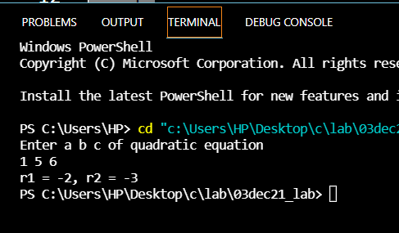

**Program 5:** Write a program to display all the prime numbers in a entered range using functions

Code:

#include <stdio.h>

//prime nos within range using functions

void prime(int a,int n){

    int i, num, count = 0;

    printf("The prime numbers in between the range %d to %d:\n",a,n);

    for (num = a; num <= n; num++)

    {

        count = 0;

        for (i = 2; i <= num / 2; i++)

        {

            if (num % i == 0)

            {

                count++;

                break;

            }

        }

        if (count == 0 && num != 1)

            printf("%d\n", num);

    }

}

void main()

{

    int start,end;

    printf("Enter the starting and ending limit");

    scanf("%d %d", &start, &end);

    prime(start, end);

}

Output:

